CST 326 – Game Development

Project 2 - Shoot ‘em up (Part 2)

California State University Monterey Bay

Objective:

This week we are going to start keeping track of information happening in the game (high score) and start working with bullets. We are increasing the complexity of our game by going against an enemy alien horde.

SUBMISSION: FORMAT AND RULES

(Part 1) You have until Sunday, 11:59:30 PM to upload your solution for Project 3b. “Uploading” consists of sending the URL for your Git repository (if it’s public you don’t have to add me).

(Part 2) Upload the link from your screen captured video (should be an ‘unlisted’ video in YouTube in your profile) with you explaining your code (should be <5 minutes).

The total value of this activity: 40 bonus points

Implement the following in your game:

(10 Points) Implement three scenes and switch between them (\*hint...should be handled in Game Manager Class and use “DontDestroyOnLoad”):

* Main Menu (initialize here)
* Main Game (Where you play)
* Credits, featuring your name (When you die or kill the horde)

Main Menu shall have a start menu:

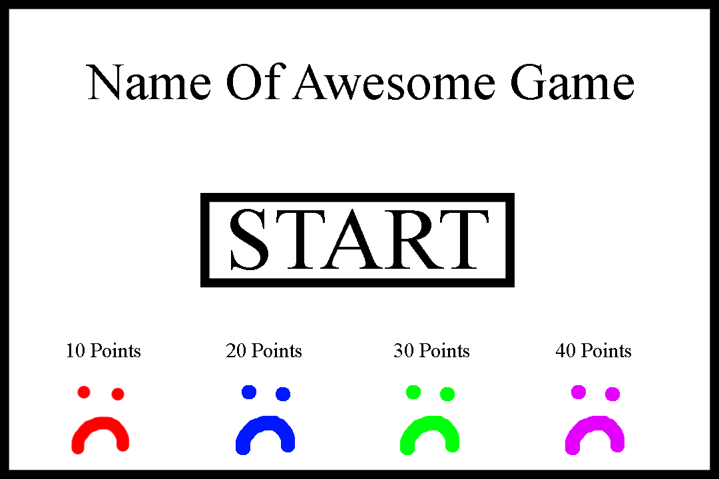

* (+ 3 points) Start button that makes it go from “Main Menu” to “Main Game” scene
* (+ 3 points) Have Enemies animate in “Idle” animation on “Start Screen”
* (+ 3 points) Have “Main Game” go-to “Credits” screen after dying
* (+ 1 points) Have “Credits” play for 5 seconds before switch to “Main Menu” again

(20 Points) Animate 2D objects with animations:

* (+2 points) Idle Player animation (3 sprites)
* (+2 points) Shooting Player animation (3 sprites)
* (+2 points) Exploding Player animation (3 sprites)
* (+2 points) Idle Enemy animation (3 sprites)
* (+2 points) Shooting Enemy animation (3 sprites)
* (+2 points) Exploding Enemy animation (3 sprites)
* (+8 points) implement “Trigger” events in animations to switch between animations

(10 Points) Talking Through your project

* Talk about your project, point by point in the formats discussed in class

(Extra Credit) (+10 points) HOORAY!!!!

* Custom sounds (at least 5) (a.k.a. You record your voice for sound effects recommend recording with Audacity)
* Shooting sound for Player
* Shooting sound for Enemy
* Blow up sound for Player
* Blow up sound for Enemy
* Some other sound that makes sense